**PROJECT 1 MILESTONE REPORT**

(tuple size: 10k, seed-val:60, train: test = 80:20 and 50:50)

**Submitted by:**

Team No. 6

Amrutha Kenchanagowdra -1001861876

Ajay Shivarudrappa - 1001720944

**PROJECT OVERVIEW**

* The dataset containing the bank data consisting of 41188 rows was imported into R studio as a .csv file using read.csv function.
* The “unknown” values in the dataset were replaced by <NA> using na.string parameter in read.table function.
* The dataset contained over 12718 unknown values.
* The attributes specified like [marital, default, housing, loan, contact] were dropped by taking a subset of the dataframe which excluded the specified attributes.
* The records with <NA> values were omitted using na.omit() function. About 1930 rows were omitted and a clean dataset was obtained for analysis.
* The identification of non-relevant attributes for the class was done based on histogram analysis and correlation matrix analysis.
* The histograms for all the attributes were plotted using hist.data.frame(dataframe) function and Hmisc package was used. Each attribute was compared with each of the other attributes for better understanding (We have also plotted histograms using ggplot to get a better representation)
* The histogram analysis for **pdays** attribute shows that most of the values for the attribute are equal to 999:Client was not previously contacted and thus it does not contribute much towards the class attribute. The **previous** attribute can also be eliminated on the same basis where the customer was contacted 0 (zero) number of times in most of the records.
* The histogram analysis for the **poutcome:** outcome of the previous marketing campaign attribute shows that most of the values are “nonexistent” for this attribute and thus does not contribute much towards the class attribute.
* The histogram analysis for the attribute **day_of_week** and also based on intuition about the domain, the day of the week in which the customer last contacted does not really contribute towards the class attribute.
* The correlation matrix for the numeric attributes was computed using cor() function and the attribute **euribor3m** exhibited strong correlation with other attributes such as emp.var.rate (0.97) and nr.employed (0.95) and so it is enough to keep emp.var.rate and nr.employed attributes. Thus **euribor3m** can be dropped as it does not make much difference towards the class attribute.
* Hence the attributes identified as non-relevant or not contributing towards the class attribute are: **pdays, poutcome, previous, days_of_week,** **euribor3m**
* The seed value was set to 60 as specified. About 10000 rows were sampled out and the random sampled data was split into training and test set based on the split ratio specified(80:20 and 50:50).
* The classification was done using Information gain, GINI index and Naïve Bayes on the dataset.

The correlation matrix for numeric attributes is shown below:

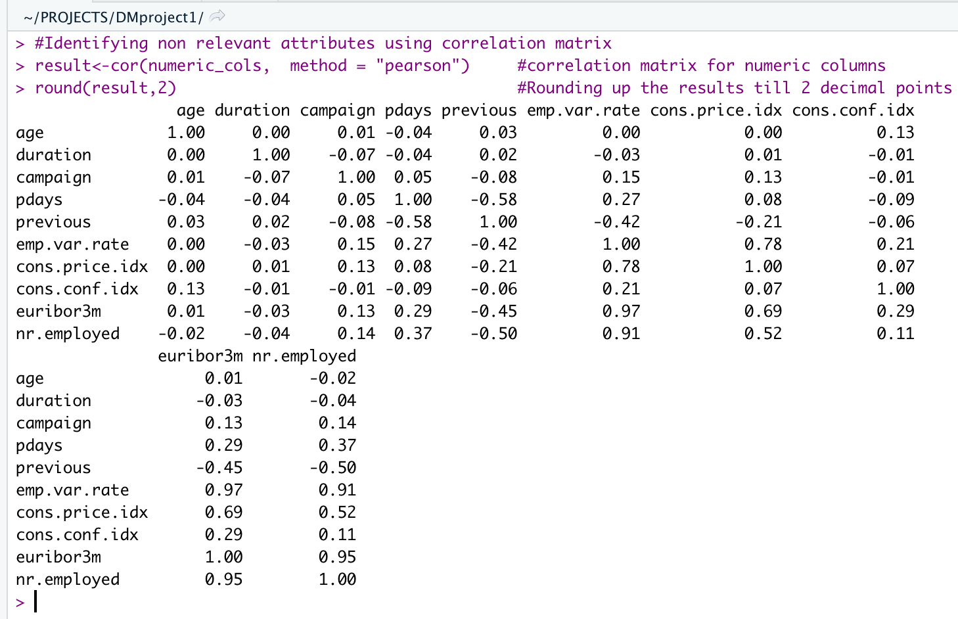

**INFORMATION GAIN**

* Using the rpart API in R, decision tree was built for the training set. By giving the parameter information gain, the API built the decision tree using information-gain instead of the default gini index. The complexity parameter value was initially used as cp=0, which built the tree till the maximum depth with all the attributes present in the training set.
* Prediction was done by passing the decision tree model and the test rows to the function “predict()”
* Confusion matrix was computed by passing the predicted rows and the actual test rows to the “table()” function which cross classifies the factors to build a contingency table of the counts.

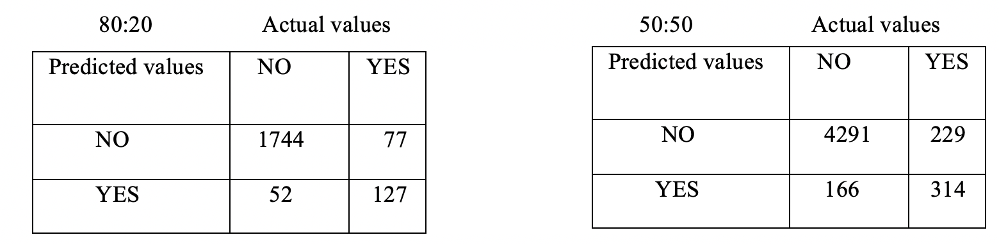

* The results of Accuracy, Precision, Recall and F1 score for **full tree** was found to be:

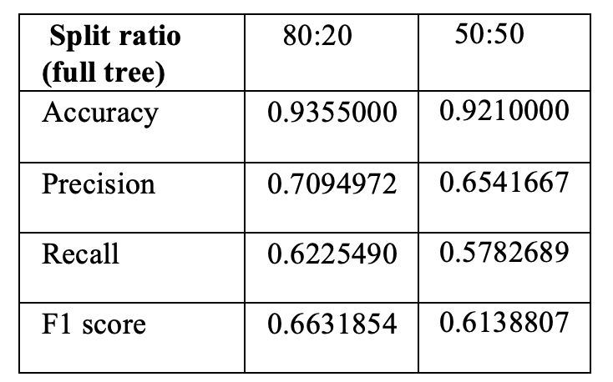

* Since the full tree with cp =0 has fit well for the given training set(overfitting), the model might not do well for the any unseen dataset and hence we have found the optimal cp value for which the error rate is lowest by printing the cp values using “printcp()” for the full decision tree.

CP values: note that this is not a full list, only few sample values have been provided

**CP** **nsplit** **rel error** **xerror** **xstd**

1 0.02341920 0 1.00000 1.00000 0.032341

2 0.00819672 9 0.78337 0.81616 0.029537

3 0.00761124 10 0.77518 0.82201 0.029632

4 0.00702576 14 0.74473 0.81967 0.029594

* The optimal CP value was found to be 0.008 for 80:20 split ratio and similarly CP value for 50:50 split was 0.009.
* The optimized model was built using the above computed cp value for both the split ratios specified.
* The pruned tree model was using minimum number of attributes for the model built with 80:20 split, whereas for 50:50 split more number of attributes were used, details are given below.

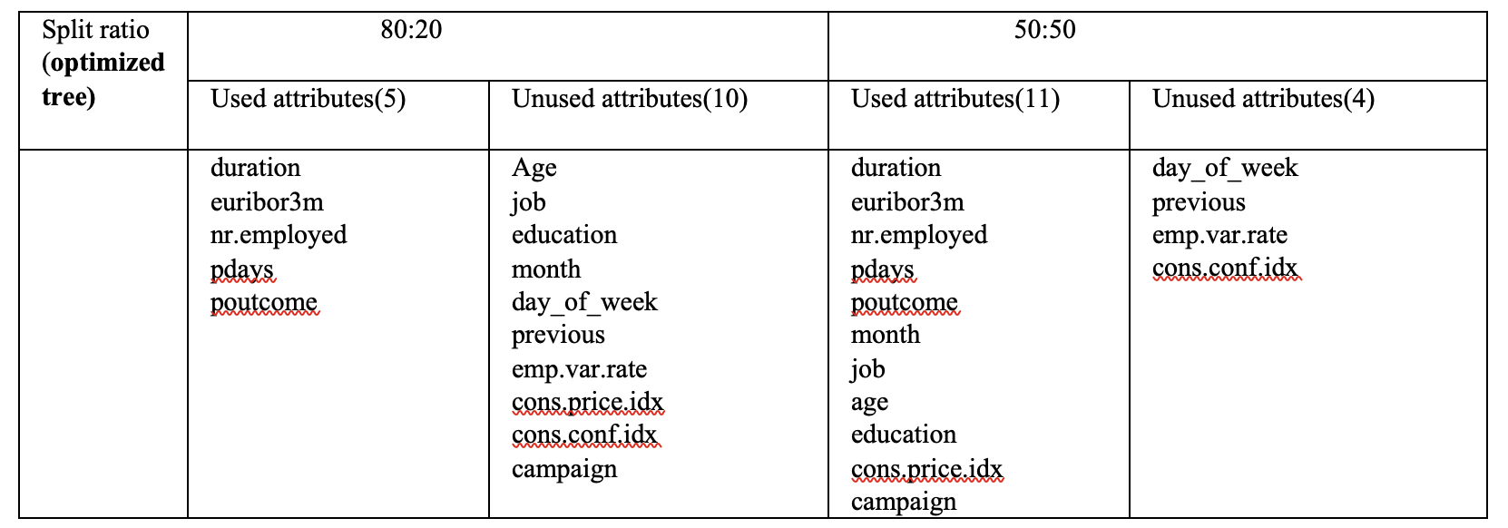

* Confusion matrix, Accuracy, Precision, Recall and F1 score for the **optimized tree** was found to be:

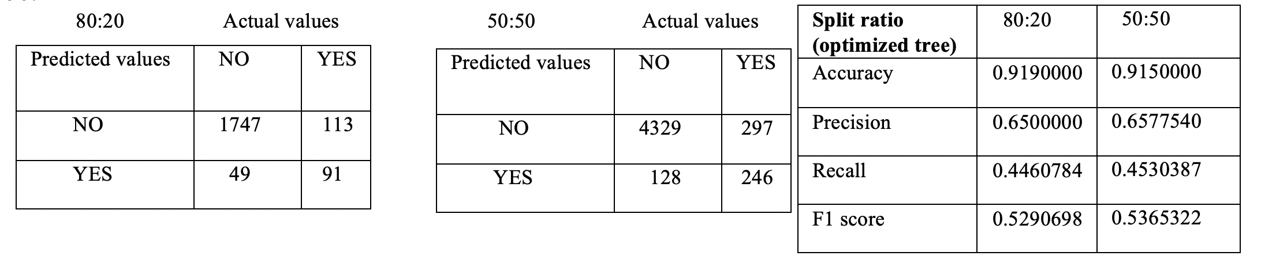

* From the above table for we can see that the accuracy value is slightly reduced for the 50:50 split and precision, recall and F1 scores are almost similar for both the splits.
* rpart.plot for Information Gain: 80:20 (optimized tree)

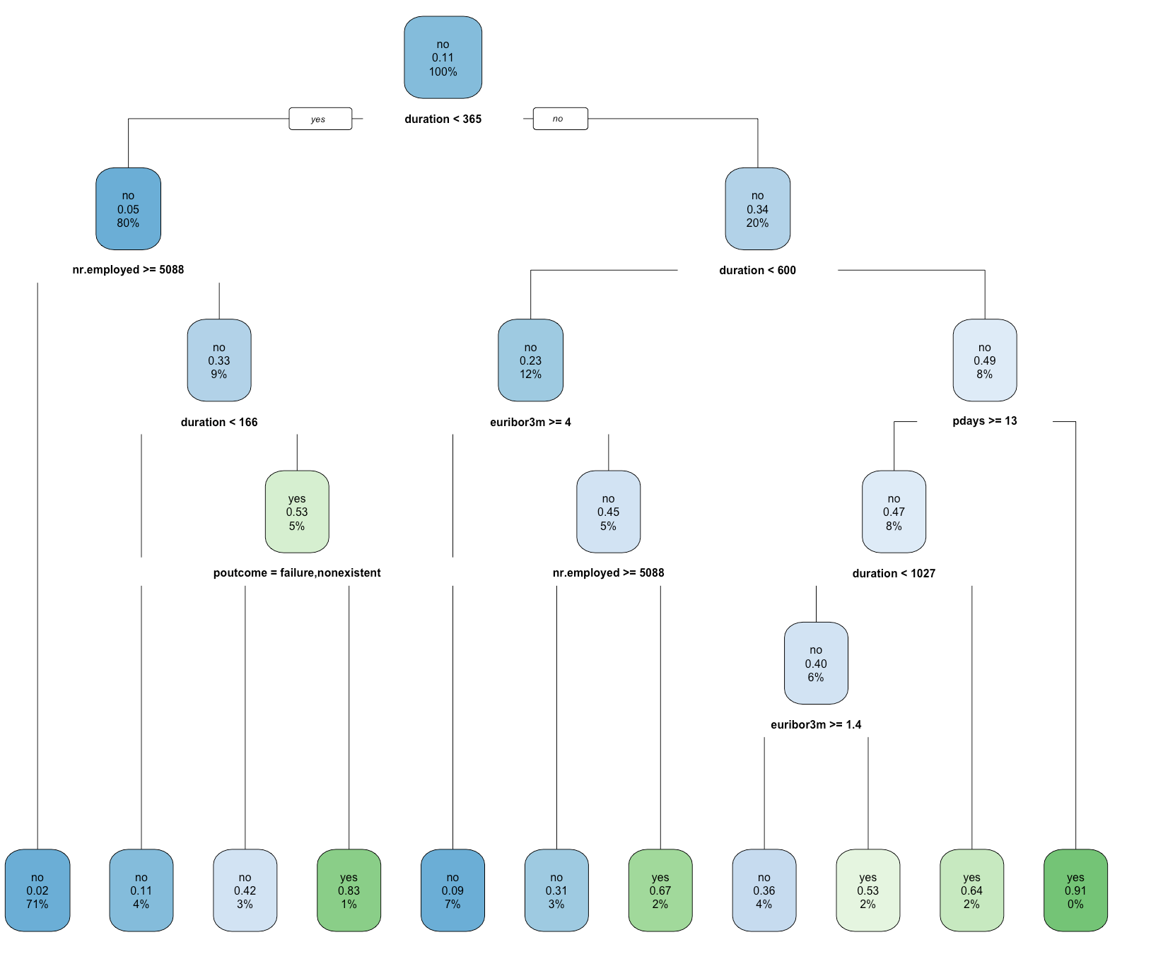

**Withholding of Attributes: Information Gain**

* Inorder to find out which attributes to be withholded we have computed the importance of the variables using variable.importance for both the splits

80:20 50:50

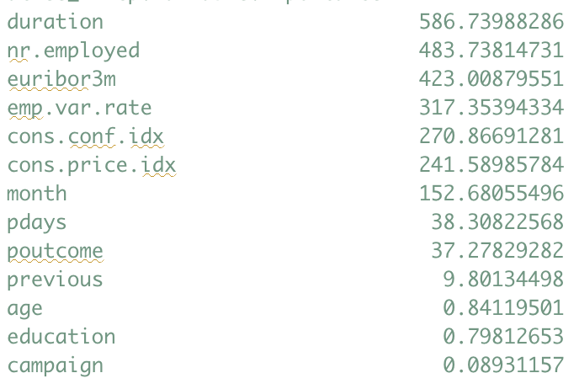 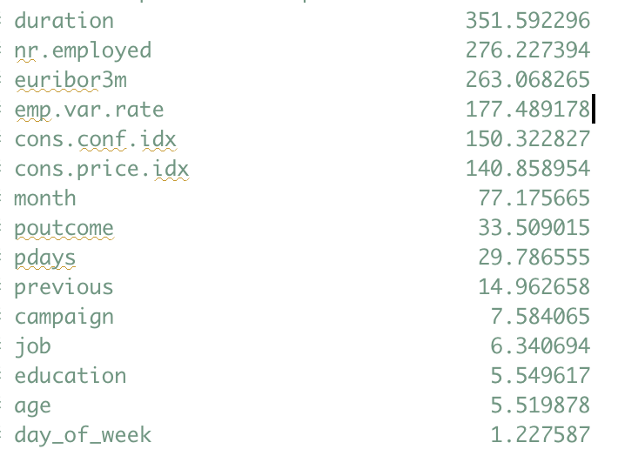

* We can see from the above variable importance table that both the spilts have high importance for duration parameter.
* So we have withholded **duration** parameter and built the model again and computed the confusion matrix and accuracy ,recall, precision and F1 scores for both the splits.
* Note: Actual values are on y axis

80:20 50:50

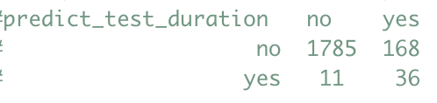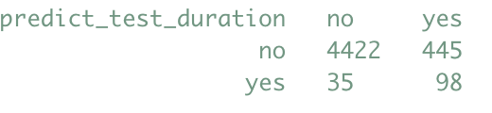

split Accuracy. Precision. Recall. F1 score

80:20. 0.9105000 0.7659574 0.1764706 0.2868526

50:50. 0.9040000 0.7368421 0.1804788 0.2899408

* We can see that even though duration attribute has high importance, accuracy has not reduced much/slightly reduced as compared to the parent model with duration parameter.
* Similarly we have withholded the **euribor3m** attribute which has high importance in both split ratios and we had identified this parameter as non-relevant for classification during the correlation matrix analysis. We have built the model and verified the confusion matrix and accuracy. Accuracy was increasing(0.9210000) compared to the parent model(0.9190000) and so we can say that the model is independent of the **euribor3m** attribute and we had identified it correctly.
* Similarly we have tried with holding **pdays** attribute which has medium importance and the accuracy(0.9210000) was increased compared to the parent model (0.9190000) and so we can say that the model is independent of the **pdays** attribute and we had identified it correctly
* We have tried withholding the attributes with least importance for both the split ratios like **campaign** and **day_of_week** and the accuracies remained same as that of the parent model, which shows that the model is not affected by the attributes with least importance.
* Please refer to the accuracy table in the dropping attributes session.

**Dropping of attributes:Information Gain**

* We have dropped all the unused attributes from both the split ratios and the optimized model was unaffected by those attributes, Accuracy and other measures remained same compared to the parent model. Please refer to the table given above to check which parameters were unused in building the optimized tree.

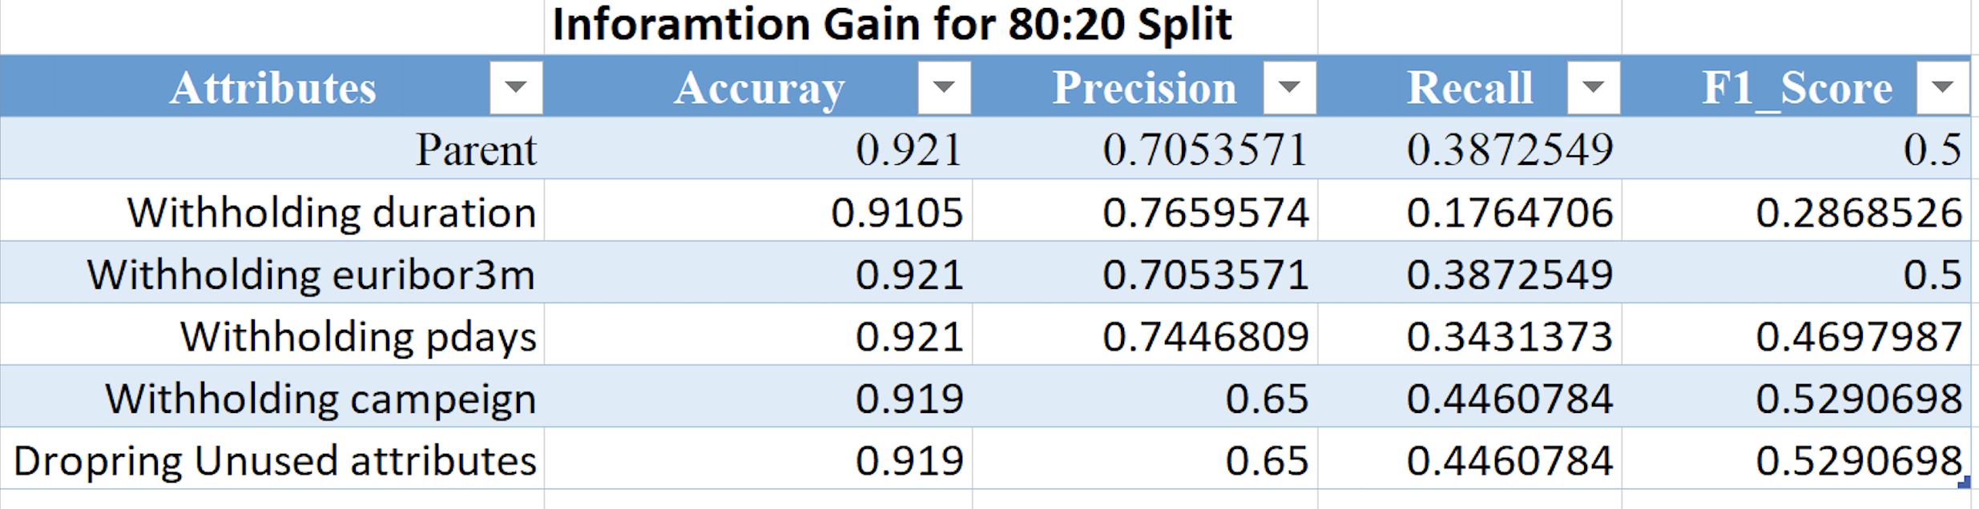

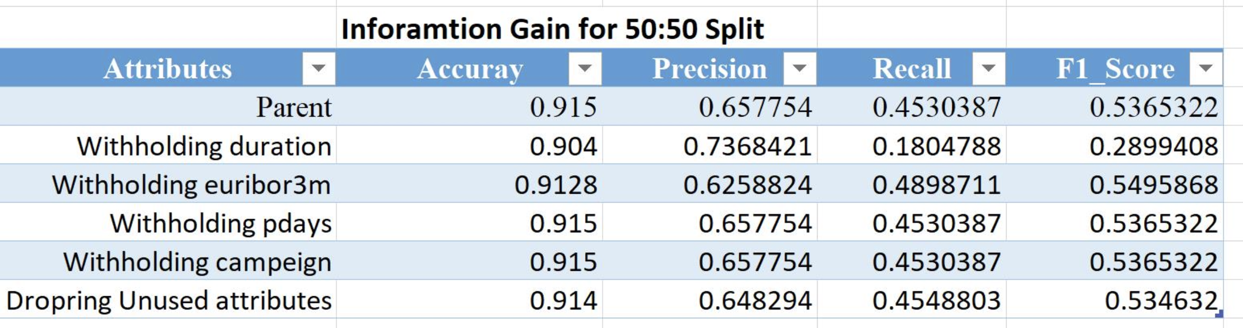

**GINI Index:**

* We have followed the similar procedure as that of the Information gain for the gini index. Where we have computed the optimal cp = 0.005 for 80:20 split and cp = 0.007 for the split ratio 50:50
* The pruned tree models were using minimum number of attributes for both the split ratios, details are given below.

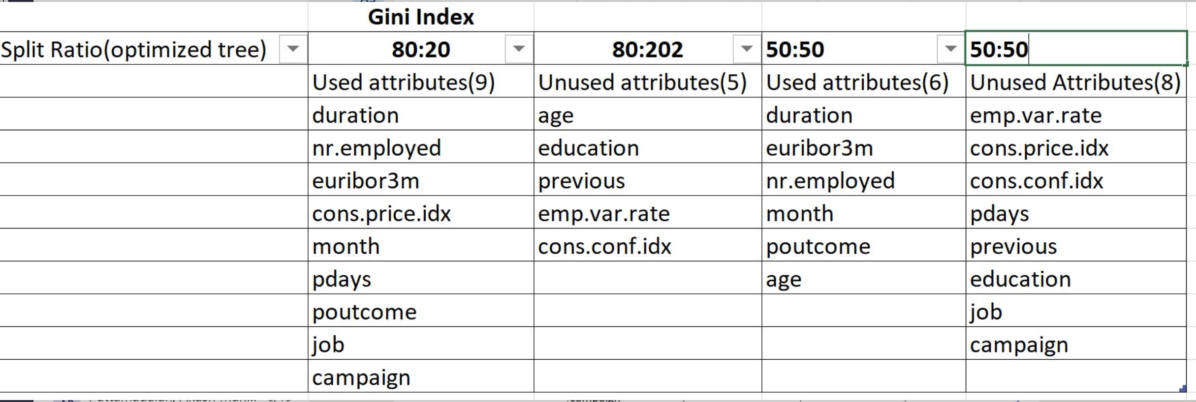

* Optimized tree was built using the above cp values and confusion matrix, accuracy and other estimates were obtained.

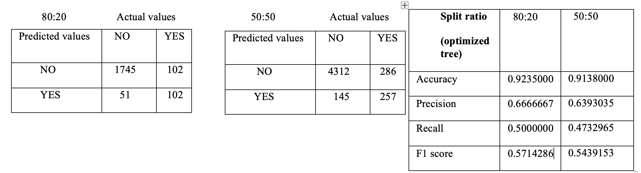

* From the above table for we can see that the accuracy value is slightly reduced for the 50:50 split and precision, recall and F1 scores are also slightly reduced compared to 80:20 split ratio.
* rpart.plot for gini index: 80:20 (optimized tree)

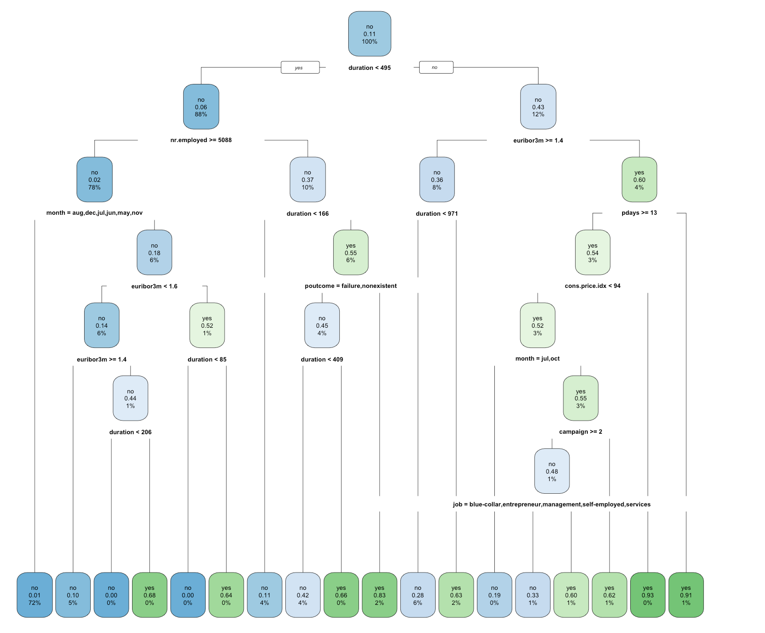

**Withholding of Attributes: GINI index**

* Inorder to find out which attributes to be withholded we have computed the importance of the variables using variable.importance for both the splits

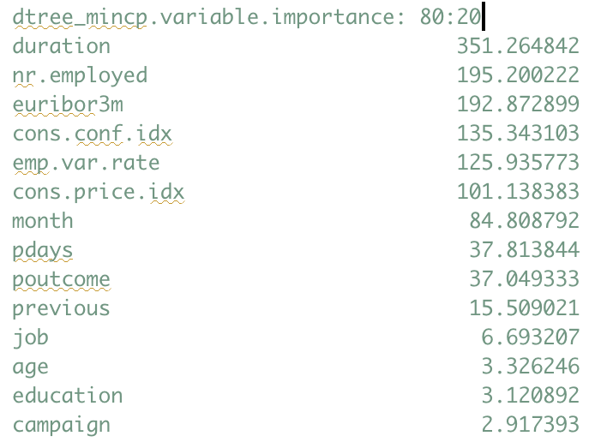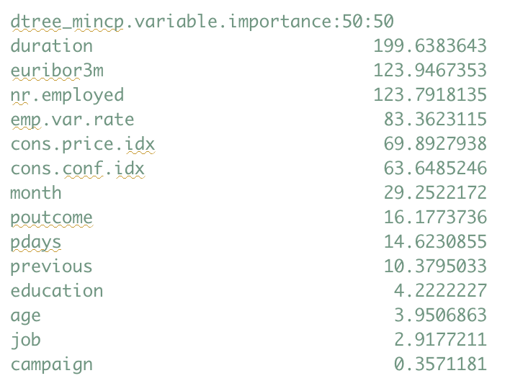

* We can see from the above variable importance table that both the spilts have high importance for duration parameter.
* So we have withholded **duration** parameter and built the model again and computed the confusion matrix and accuracy ,recall, precision and F1 scores for both the splits.
* Note: Actual values are on y axis

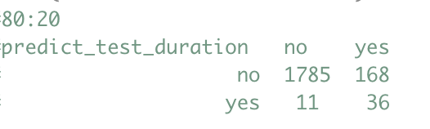 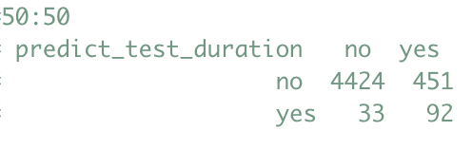

split Accuracy. Precision. Recall. F1 score

80:20. 0.9105000 0.7659574 0.1764706 0.2868526

50:50. 0.9032000 0.7360000 0.1694291 0.2754491

* We can see that even though duration attribute has high importance, accuracy has not reduced much/slightly reduced as compared to the parent model with duration parameter.
* Similarly we have withholded the **euribor3m** attribute which has high importance in both split ratios and we had identified this parameter as non-relevant for classification during the correlation matrix analysis. We have built the model and verified the confusion matrix and accuracy. Accuracy was increasing(0.9245000) compared to the parent model(0.9235000) and so we can say that the model is independent of the **euribor3m** attribute and we had identified it correctly.
* For the euribor3m attribute the accuracy(0.9138000) slightly decreased for the 50:50 split as compared to parent model(0.9138000).
* Similarly we have tried with holding **pdays** attribute which has medium importance and the accuracy(0.9155000) was slightly decreased compared to the parent model (0.9235000) and so pdays attribute is not considerably important for the classification with respect to gini model.
* We have tried withholding the attributes with least importance for both the split ratios like **campaign** and the accuracies slightly reduced as that of the parent model, which shows that the model is not much affected by the attributes with least importance.
* Please refer to the accuracy table in the dropping attributes session.
* Hence in **comparison with information gain, gini index** also exhibited similar behaviour when the duration attribute was withholded, i.e accuracy was slightly decreased in both cases and the model was independent of the duration attribute.

**Dropping of attributes:GINI index**

* We have dropped all the unused attributes from both the split ratios and the optimized model was unaffected by those attributes, Accuracy and other measures remained same compared to the parent model. Please refer to the table given above to check which parameters were unused in building the optimized tree.

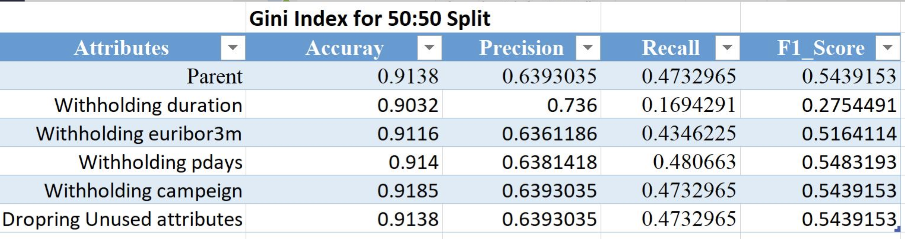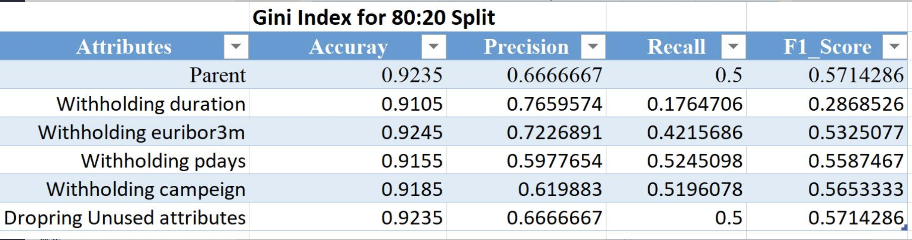

**Naïve bayes**

* **naiveBayes(y ~., data=train)** API in **library(e1071)** was used to perform Naïve Bayes classification and the confusion matrix was obtained as shown below:
* Note: Actual values are on y axis

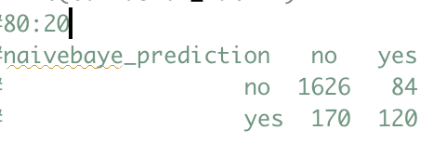 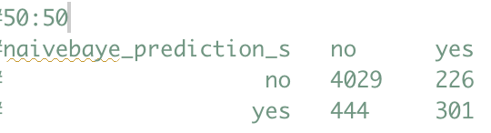

* The results of Accuracy, Precision, Recall and F1 score was found to be:

split Accuracy. Precision. Recall. F1 score

80:20. 0.8730000 0.4137931 0.5882353 0.4858300

50:50. 0.8660000 0.4040268 0.5711575 0.4732704

* We can see that the accuracy, precision, recall and F1 score values for the 50:50 split is slightly reduced compared to 80:20 split ratio and thus we can consider that naïve bayes works well with large training set.

**COMPARISON**

1. **Compare Information Gain and GINI index**

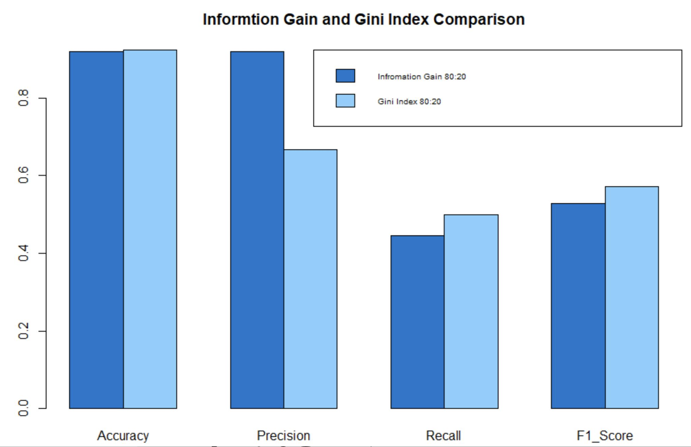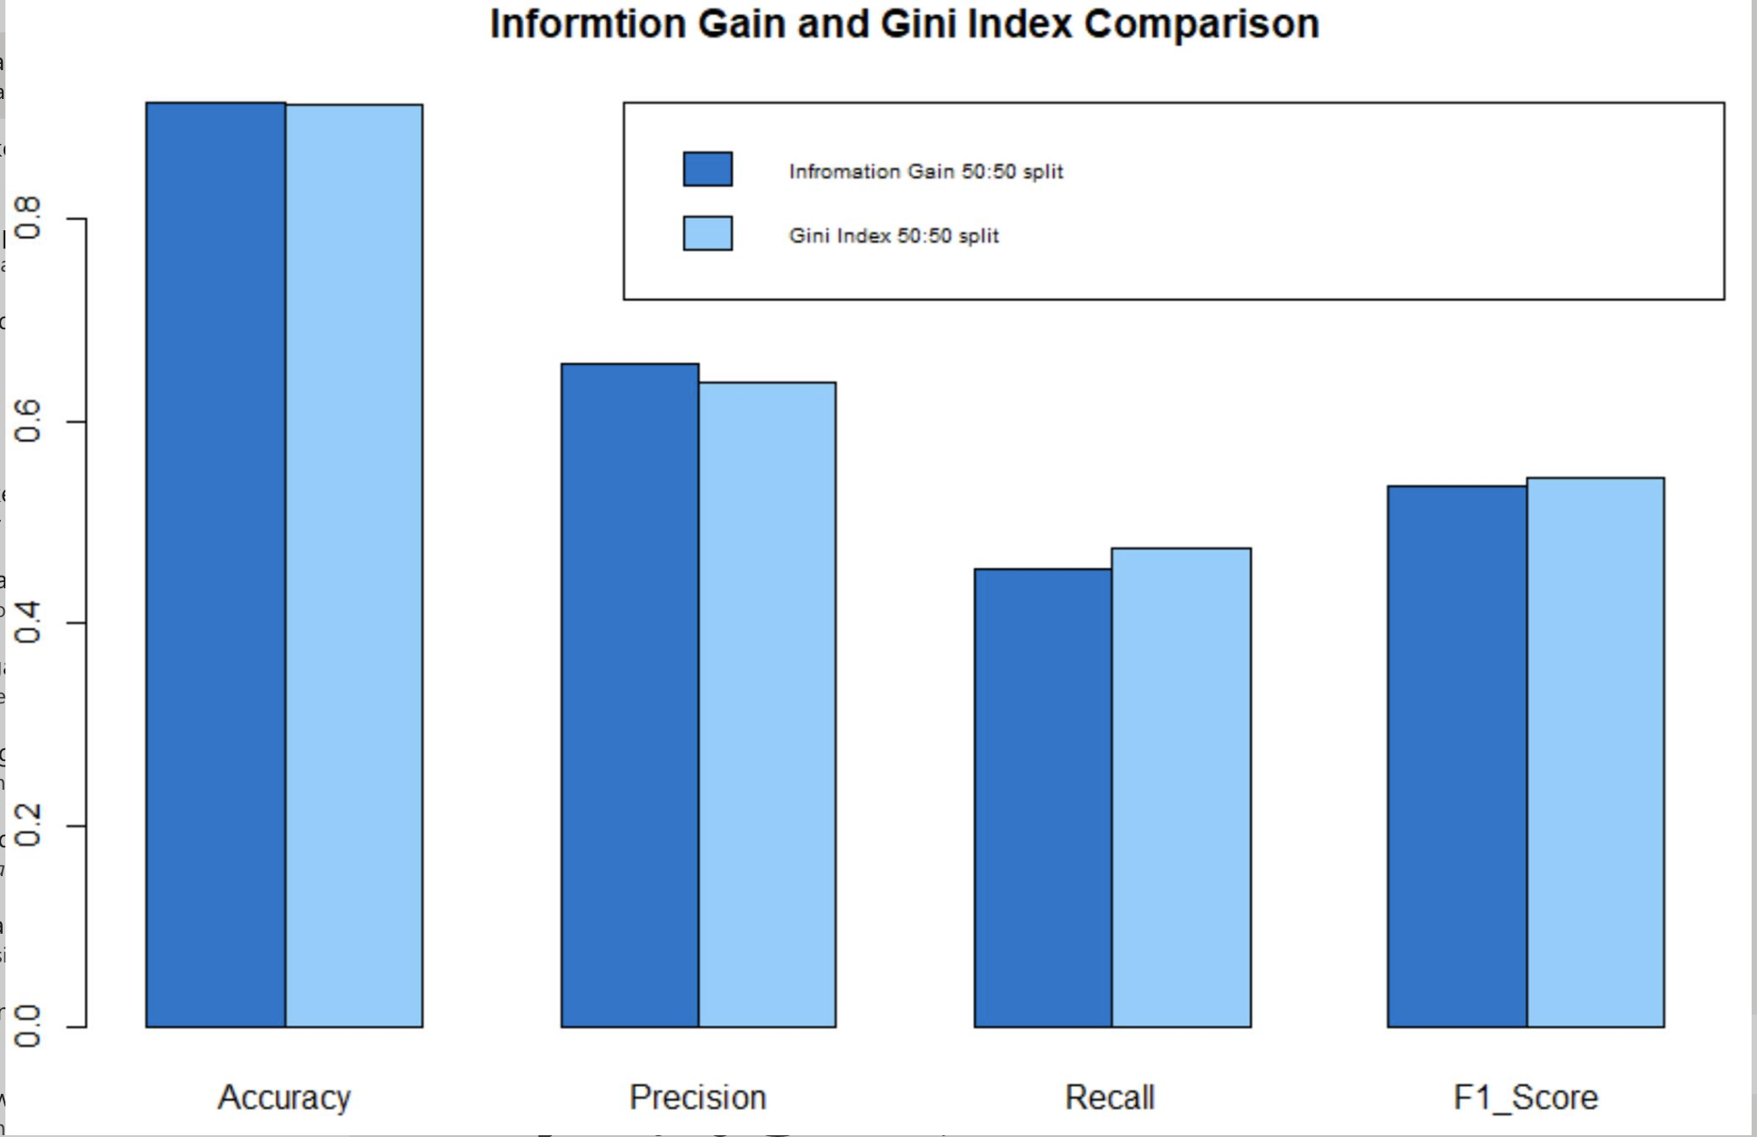

ratio 50:50 for the optimal tree and thus IG favours smaller partitions with many distinct values.

Gini index classification performs slightly better than IG for split value: 80:20 and thus Gini index favours larger partitions.

Otherwise both are almost similar, we can either use Gini or information gain.

We can also see from the withholding of duration attribute that the behaviour of IG and GINI is similar., i.e both the methods slightly decreased the accuracy when the duration was withholden.

We can see that Information gain classification performs slightly better than Gini Index for split

1. **Compare Information Gain and Naïve Bayes**

Information gain performs evidently better than the naïve bayes classification for both the split ratios 80:20 and 50:50.

Even though recall rates in both the split ratios for naïve bayes is better than information gain, after calculating the F1 score, we can see that the information gain gave better results for both the spilt ratios, Information gain needs sufficiently large data and thus works well when the class variable is categorical and has less number of labels.

Information gain is better than Naïve Bayes because the rpart API builds a best optimized tree by sub splitting the training data to train and test and building the tree such that all of training data isn’t classified rightly which may result in overfitting.

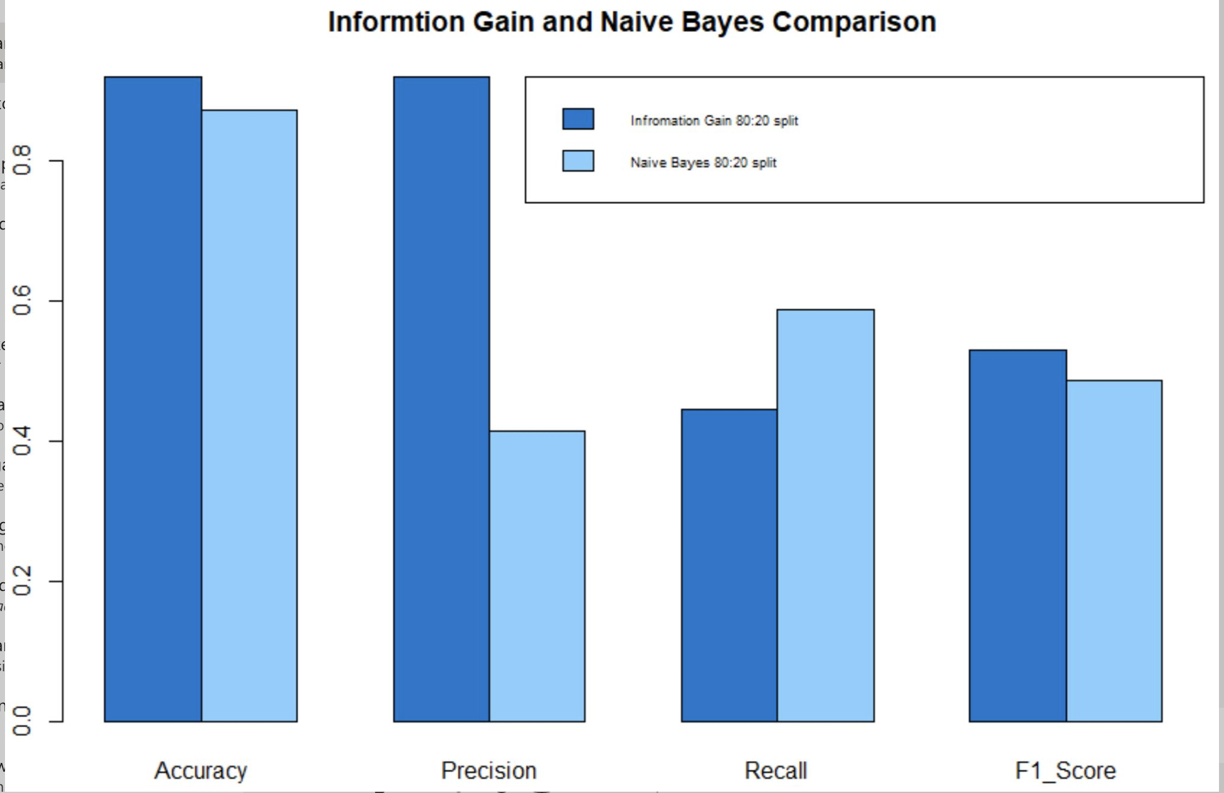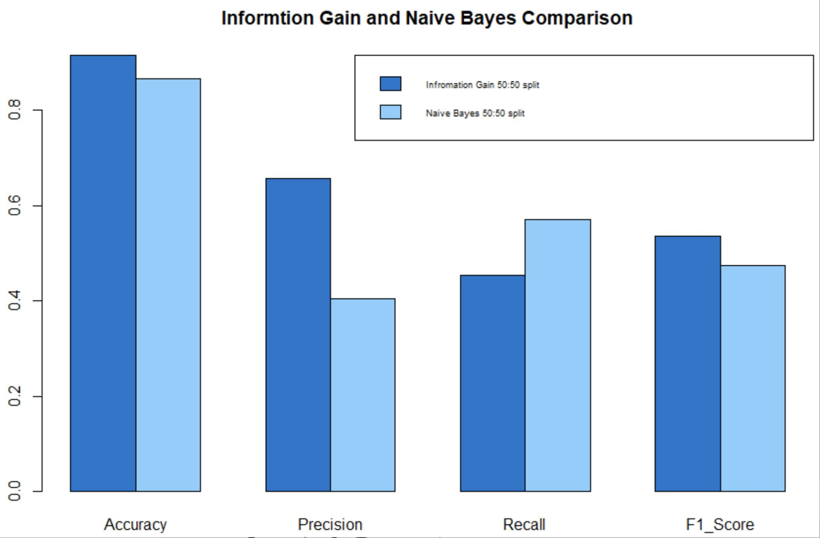

1. **Compare Gini Index and Naïve Bayes**

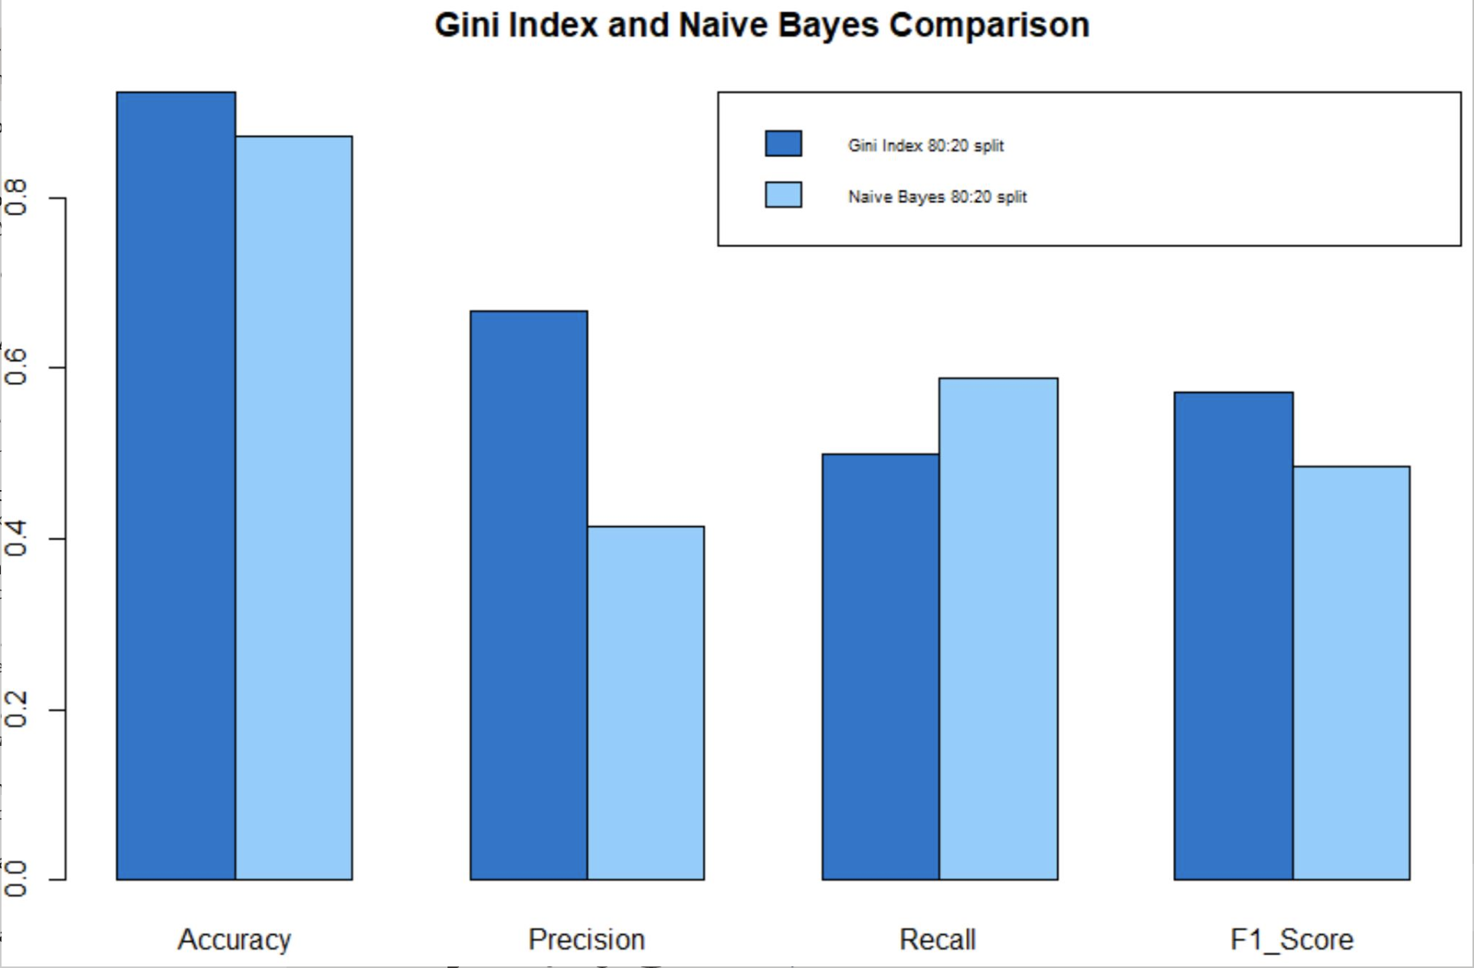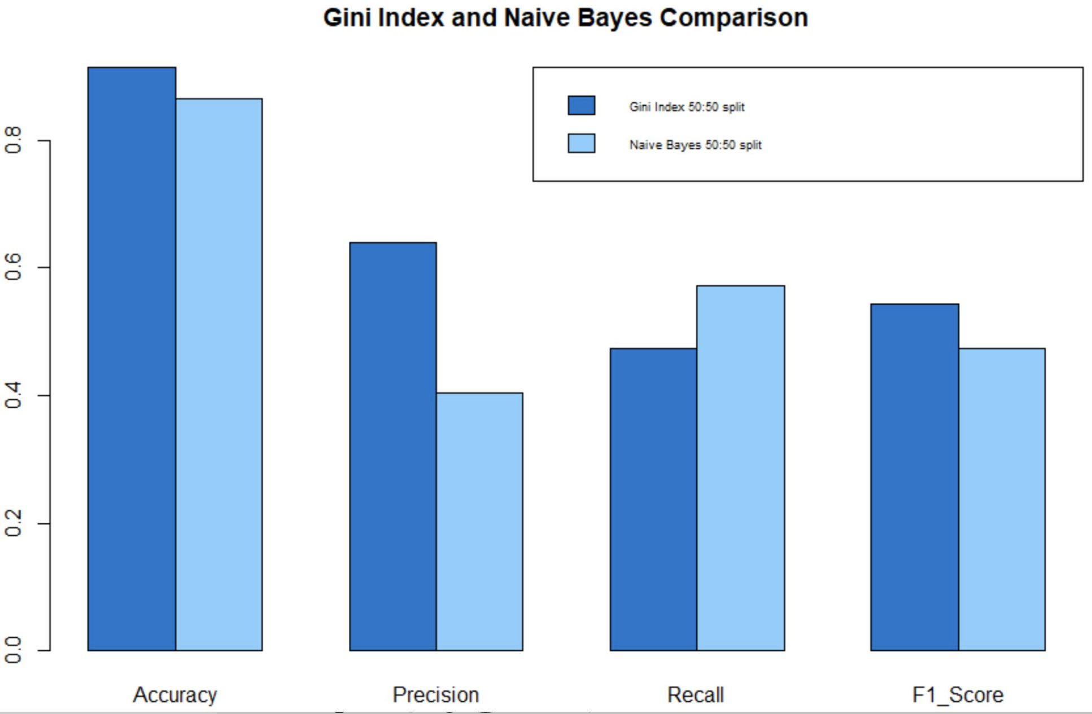

Gini index performs evidently better than naïve bayes with respect to accuracy, precision and F1 score for both of the split ratios. Naïve bayes has predicted more true negatives whereas gini index has predicted less number of true positives.

Naïve bayes handles conditional probability and thus it can perform well with small data sets too.

**CHALLENGES**

* Understanding of which approach to use for identifying the non-relevant attributes was challenging and was solved by deciding on histogram analysis as well as correlation matrix analysis for the attributes.
* The levels mismatch error was faced for the education attribute for the seed value: 60 and the split ratio value = 50:50.

**Explanation**: when the random sampling of 10k records were taken using the seed 60 and accordingly divided into training and test sets of 5k records each for both Information gain and Gini index classifications, the number of rows for attribute “education” with value = “illiterate” were totally missing in training set but all of them were present in test set.

Because of which the model did not include these rows and when we were trying to run the prediction function it was failing with the error: new level “illiterate” found in test set for education attribute.

predict_test_full <-predict(dtree_full, test_rows , type = 'class')

Error in model.frame.default(Terms, newdata, na.action = na.action, xlev = attr(object, :

factor education has new levels illiterate

**Reason**: all the rows with illiterate value for the attribute education were present in test set but not in training set.

> table(train_rows$education)

basic.4y basic.6y basic.9y high.school professional.course

524 298 744 1208 728

university.degree

1498

> table(test_rows$education)

basic.4y basic.6y basic.9y high.school illiterate

528 304 765 1193 3

professional.course university.degree

667 1540

**Solution: we have changed the seed value to 70 while splitting the 10k records into training and test sets so that the rows with illiterate value for the attribute education should get equally distributed.**

**FILE NAMES**

**src directory:**

**information_gain_8020.R** - Code where the pre-processing and milestone code as well as IG for 80:20 is present

**information_gain_5050.R** – code for IG 50:50 is present

**gini_index_8020.R** – code for gini index 80:20 split ratio is present here

**gini_index_5050.R** – code for gini index 50:50 split ratio is present here

**naïve_bayes.R** – code for naïve bayes both the split ratios is present here.

**milestone_project1.R –** contains milestone1 code for histograms and pre-processing and correlation matrix

**Plots:**

GiniIndex_Treetext.txt : contains tree text for cp =0 and for optimal cp = 0.005 for gini index 80:20

Information_GainTreetext: contains tree text for cp =0 and for optimal cp = 0.008 for information gain 80:20

GiniIndex8020_cpplot.png : cp plot for gini index

InformationGain8020_cpplot.png: cp plot for information gain for finding optimal cp

**Division of Labor**

Amrutha: I have handled the classification using Information gain for both the split ratios and I have done the analysis part and prepared the report for both milestone and final submission.

Ajay: Handled Gini index classification for both the split ratios and naïve bayes classification.